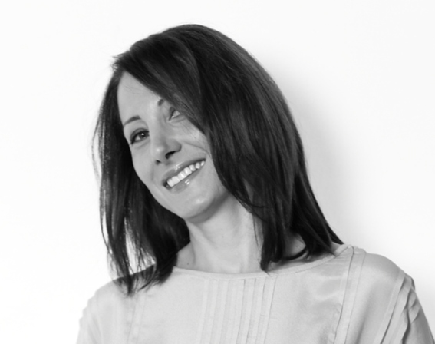
LUBNA FORZLEY
BIOGRAPHY

www.lubnaforzley.com

🌟 Purpose Coach ✨ Marketing and Communications Consultant
🎤 TEDx Speaker, Trainer, Moderator
🥤 Coca-Cola Alumni

Lubna is a purpose coach and works with executives, entrepreneurs and leaders who want to create goals that are aligned with their purpose. She is a certified coach and regularly coaches with BetterUp, which brings together world-class coaching, AI technology, and behavioral science experts to deliver change at scale.

She has worked for more than 20 years in leadership and / or consulting roles within International blue-chip organizations and across various industries, including e-commerce, banking, FMCG, and human development. She has managed her own consulting firm, called Stories, and held leading roles in Coca-Cola, the UNDP, BNP Paribas, and so many others. Through these, she has coached thousands of individuals to find and articulate their purpose. She has also developed a track record in creating and implementing integrated internal and external Marketing and Communications plans, using effective CRM, Digital/Social Media, Content, Campaigns, Influencer Management & Affiliate Marketing, Video production, Design, PR, Events, and Community Engagement.
Lubna has spoken in and moderated large conferences, including TEDx, and Euromoney Conferences, and trained teams in global organizations including Coca-Cola and UNDP. Through her talks, she has shared the stage with Ministers, Leading Entrepreneurs, and Global innovators including Steve Wozniak, co-founder of Apple.
Finally, she is a proud mum and an advocate for Women in Leadership positions. As a change agent, she uses her voice to uplift other women, especially by partnering with key organizations like ‘Women@work’ to coach women on finding purpose and building a winning personal brand.

Nothing makes Lubna happier than hearing a good story and she truly believes that everyone has a beautiful story to share! She can’t wait to hear yours. Go ahead and book a call here, https://calendly.com/lubnaforzley

